| Government College of Engineering, Jalgaon-425002  (An Autonomous Institute of Government of Maharashtra)  Estt. 1996, Autonomy:2014, 6 UG, 3PG, 5 PhD Programs  [www.gcoej.a.in](http://www.gcoej.a.in), [principal@gcoej.ac.in](mailto:principal@gcoej.ac.in), [principal.gcoejalgaon@dtemaharashtra.gov.in](mailto:principal.gcoejalgaon@dtemaharashtra.gov.in)  Contact: 0257-2281522(ext. 200/201/203/222/260) | | |
| --- | --- | --- |
| Image result for GCOEJ Logo | INSTITUTIONAL DEVELOPMENT PLAN (IDP) | आपणास संचालनालयाच्या नवीन संकेतस्थळा कडे पुनर्निदेशित ... |
|  | | |
|  |  |  |
| **शासकीय अभियांत्रिकी महाविद्यालय, जळगाव**  स्थापना: १९९६, (**महाराष्ट्र शासनाची स्वायत्त संस्था** ) स्वायत्त:२०१४ | | |
|  |  |  |

**CONTENTS**

| **Sl.**  **No.** | **Particulars** | **Page**  **No.** |
| --- | --- | --- |
| i | **Institutional Profile** | 3 |
| ii | Vision and Mission | 4 |
| 1 | Institutional Basic Information | 5-7 |
| 2 | Resources Available with the Institute | 8-17 |
| 3 | Quality Assurance | 18-21 |
| 4 | Institutional Development Proposal (IDP) | 21 |
| 4.1 | SWOT Analysis | 22 |
| 4.1.1 | Methodology | 22-24 |
| 4.1.2 | Strategic Plan For Institutional Development Based On SWOT Analysis | 25 |
| 4.1.3 | Specific Objectives and Expected Results Linked To The SWOT Analysis | 26 |
| 4.2 | Action plan for Development: | 27 |
|  | 1. Improving Employability Of Graduates 2. Increased Learning Outcome Of The Students 3. Obtaining Autonomous Institution Status Within 3 Years. 4. Achieving The Targets of 60% Of Eligible UG And PG Programs. 5. Implementation Of Academic And Non-Academic Demands. 6. Improving Interaction With Industry. 7. Enhancement Of Research And Consultancy Activities. | 27-36 |
| 4.3 | Action Plan For Finishing School For SC/ST/OBC and improving performance of academically Weak Students and SC/ST,OBC/SBC,VJ-NT/EWS | 37-38 |
| 4.4 | Action Plan For Strengthening of PG/PhD Programmesa and Starting of New  PG/PhD Programs. | 39 |
| 4.5 | Summary of Training Needs Analysis. | 40-41 |
| 4.6 | Action plan for training technical and other staff in functional areas. | 42 |
| 4.7 | Relevance and coherence of IDP with State/National  Industrial/Economic Development Plan. | 43 |
| 4.8 | Participation of departments / faculty in IDP Preparation. | 44 |
| 4.9 | Institutional Project Implementation arrangements with Participation of faculty  and Staff. | 45 |
| 5 | Action plan (With Budget) | 46-51 |

**i.) INSTITUTIONAL PROFILE**

Government College of Engineering, Jalgaon was established in 1996 by Government of Maharashtra to impart world class education in Engineering and with vision to create ‘Globally Accepted Engineers with Human Skills’. The institute has received autonomous status from the academic year 2014-15. The Institute offers undergraduate Engineering, that is. B. Tech courses in Civil Engineering, Computer Engineering, Electrical Engineering, Electronics & Telecommunication Engineering, Instrumentation Engineering and Mechanical Engineering. The Institute also offers post graduate courses in Electrical and Instrumentation Engineering, Electronics and Telecommunication Engg. and Mechanical engineering, In addition to M. Tech Courses Institute offers research leading courses (PhD) in Civil Engineering, Electrical Engineering, Electronics & Telecommunication Engineering, Instrumentation Engineering and Mechanical Engineering.

As per performance of the institute, Government College of Engineering, Jalgaon is the only institute to become autonomous in all sectors within the span of 20 years of its establishment (all sectors include all Private/Government/Government-aided or any professional and/or non professional educational institute those are imparting education in Engineering/Technology or any other sectors). Due to the performance of the institute, Government College of Engineering, Jalgaon was selected in World bank and Ministry of Education (then MHRD), Government of India’s initiatives, titled, Technical Education Quality Improvement Program (TEQIP-II) as well as in TEQIP-III. This institute is affiliated to KBC North Maharashtra University, Jalgaon-Maharashtra and all the graduation/post graduation/doctoral degrees are recognized and processed by the affiliation university.

Jalgaon is a city that has diversified its economy with a mix of traditional and modern industries. The city's major industries include textiles, pharmaceuticals, and automobile components, with several small-scale industries also contributing to the city's economic growth.

**Government College of Engineering Jalgaon**

**(An Autonomous Institute of Govt. of Maharashtra)**

***ii..) Vision & Mission***

Vision Statement :

**Globally Accepted Engineers with Human Skills**

**Mission Statement :**

To promote overall development of students by creating an excellent learning environment.

To develop undergraduate and postgraduate programmes through effective linkages with industry, academia, and alumni.

Promote services to community and revenue generation for sustainable development.

**Objectives:**

Determine and prescribe department-wise own courses of study and syllabi.

Establish and implement the method of examination and evaluation as per industry policies.

Accommodate administrative and financial reforms with respect to autonomy.

Establish centers of excellence in various engineering disciplines.

**Quality Policy :**

Offering value based technical education of the best and excellent of possible standards.

**Short Terms Goals:**

* To get 12(b) status of UGC
* To get accreditation of NAAC with “A+” grade
* Establish new PG Programs in Mechanical and Instrumentation Engineering/Technology
* To be a 100 % hostel capacity for all students.

**Long Terms Goals :**

* To get status of Unitary Technological University
* To start collaborative degree programs with institute which included in top 200 ranking
* To start collaborative work to have 10 % student population to opting Entrepreneurship or Start-ups of sustainable nature
* Student population opting and establishing at least one startup in unicorn per decade.

# 1. INSTITUTIONAL BASIC INFORMATION

* **Name of the Institution:** Government College of Engineering, Jalgaon -425002
* **Establishment:** 1996
* **Latitude and Longitude: 21.0077° N, 75.5626° E**
* **AICTE, New Delhi Permanent Id of Institute: :** 1-5025816
* **Directorate of Technical Education (DTE), Maharashtra Code :** 5004
* **AISHE Code:** C-8965
* **Affiliating University:** KBC North Maharashtra University, Jalgaon, Maharashtra
* **Type of Institution** **:** Government
* **Status of Institution** **:** Autonomous.
* **Autonomous status from:** 2014
* **website:** [www.gcoej.ac.in](http://www.gcoej.a.in)
* **Head of Institution:** Dr. G. M. Malwatkar
* **Contact No. :** 0257-2281522 (Ext. 200/201/203/260/222)
* **Email:** [principal@gcoej.ac.in](mailto:principal@gcoej.ac.in), [principal.gcoejalgaon@dtemaharashtra.gov.in](mailto:principal.gcoejalgaon@dtemaharashtra.gov.in)

The institute offers undergraduate (UG) programs, postgraduate (PG) programs and Ph.D. programs in Engineering/Technology. The details of these programs are as under:

* 1. **Academic Information:**

**UG/PG/PhD programs offered**

**UG Programs (4 Years)**

| **Sl. No.** | **Branch** | **Intake** | **Year of Establishment** | **Accreditation Status** |
| --- | --- | --- | --- | --- |
| 1 | Mechanical Engineering (ME) | 60 | 1996 | Accredited  (2018-2021) |
| 2 | Instrumentation Engineering (IN) | 60 | 1996 | Accredited  (2018-2021) |
| 3 | Electronics and Telecommunication Engineering (ET) | 60 | 1996 | **--** |
| 4 | Computer Engineering (CO) | 60 | 2007 | – |
| 5 | Electrical Engineering (EE) | 60 | 2007 | – |
| 6 | Civil Engineering (CE) | 60 | 2010 | – |

**PG Programs**

| **Sl.**  **No.** | **Branch** | **Intake** | **Year of Establishment** |
| --- | --- | --- | --- |
| 1 | Electronics and Telecommunication Engineering (Digital Systems) | 18 | 2010 |
| 2 | Mechanical Engineering (Heat Power ) | 18 | 2022 |
| 3 | Electrical Instrumentation and Control Engineering | 18 | 2022 |

**Research Programs (Ph. D.): Affiliating University Recognized Centers**

| **Sl. No.** | **Branch** | **Year of Establishment** |
| --- | --- | --- |
| 1 | Mechanical Engineering (ME) | 2018 |
| 2 | Instrumentation Engineering (IN) | 2018 |
| 3 | Electronics and Telecommunication Engineering (ET) | 2018 |
| 4 | Electrical Engineering (EE) | 2018 |
| 5 | Civil Engineering (CE)s | 2018 |

Apart from educational activities, the institute continuously organizes extra-curricular activities like seminars, workshops, and lectures by dignitaries in the respective field. With the changing technological front, the institute keeps regularly updating laboratories, infrastructure, computers, machineries/ equipments etc. Development of the institute since its establishment is as follows:

1996 - Established and Affiliated to KBCNMU, Jalgaon (3 UG programs)

2007 - Occupied present building- 19.35 Acres and addition of 2 new UG courses

2009 - Accreditation of 3 UG programs (E &Tc, Mechanical & Instrumentation Engineering)

2010 - Commencement of UG program in Civil and PG Program in E&Tc

2012-16 - Inclusion in TEQIP II (Rs. 15 Crore)

2014 - Autonomy granted by UGC & KBCNMU, Jalgaon

2018 – Reaccreditation by NBA (Mechanical & Instrumentation) - SAR uploaded for

accreditation of E&Tc in 2020

2018- Selected under TEQIP III (Rs. 7 Crore) - NAAC accreditation with B+ (2.67) •

2018 – 5 Recognized research centers for Ph. D. (23 students)

2021 – Extension of Autonomy by UGC, New Delhi.

2022- 2 PG Programs added (Mechanical and Instrumentation)

##### General Information As on September 30th 2022

| **Sl**  **No** | **Parameter** | **Values** |
| --- | --- | --- |
| 1 | Total strength of students in all programs and all years of study in the year 2021-2022 | 1474 |
| 2 | Total women students in all programs and all years of study in the year 2021-2022 | 483 |
| 3 | Total SC students in all programs and all years of study in the year 2021-2022 | 225 |
| 4 | Total ST students in all programs and all years of study in the year 2021-2022 | 75 |
| 5 | Total OBC students in all programs and all years of study in the year 2021-2022 | 680 |
| 6 | Number fully functional P-4 and above computers available for UG and PG | 550 |
| 7 | Total number of text books and reference books available for UG and PG | 36971 |
| 8 | Student – teacher ratio (Only Regular faculty) | 40.9 |
| 9 | No. of UG Students placed through campus interviews in the year 2021-2022 | 250 |
| 10 | Number of research publications in National and International refereed journals in the year 2021-2022 | 20 |
| 11 | The transition rate of Students in percentage from 1st year to 2nd year in the year 2022.  * Due to Covid Situation, the decision of carry on is/was taken as per Government of Maharashtra GR/University Circular/Academic Council of Institute | 100% |
| 12 | Students’ fee and other charges in the year 2021-2022(As per Govt. of Maharashtra norms). | - |
| 13 | Total IRG in the year 2021-2022 (Rs .In lakh) | 100 |
| 14 | Total annual recurring expenditure of the institution in the year 2021-2022 (Rs.in lakh) | 2073 |

**2. Resources Available with the` Institute**

**2.1 Land Details**

* **Total Land details for Government College of Engineering Jalgaon**

|  |  |  |  |  |  |
| --- | --- | --- | --- | --- | --- |
| **Sl. No** | **Document No** | **Date of registration** | **Plot No** | **Address (Village) Dist.-** | **Area in acres** |
| 1 | DTE Letter No.1(1) PERMISSION/02-03/23372 Dated 18/09/2002 | 18/09/2002 | Gat Nos  75, 74, 74/1,  68/2, 67,76/2 | Village-Pimprala, Tal-Jalgaon, Dist.-Jalgaon | 19.38 Acres |
|  | **Total area in acres** | | | | **19.38** |

* **Description of Civil Infrastructure**

|  |  |  |
| --- | --- | --- |
| **Sl. No.** | **Room type (mention Class room/Lab/Toilet, etc** | **Carpet/Built up area (in sqm)** |
| 1 | Main and administrative building | 10783.57 |
| 2 | Workshop | 2225.05 |
| 3 | Library | 935.37 |
| 4 | Seminal Hall_TEQIP(GF+FF) | 500.00 |
| 5 | Boys hostel-I | 3203.24 |
| 6 | Boys hostel-II | 3203.24 |
| 7 | Girls Hostel | 2623.55 |
| 8 | Principal Quarter | 149.39 |
| 9 | Rector/Professor Quarters | 1560 |
| 10 | PWD Seva Kendra/Site office | 168.44 |
| 11 | Electric Substation | 37.60 |
| 12 | Class-IV Quarters | 875.59 |
| 13 | Girls hostel for Minority students | 1917.00 |
|  | Total B/up area | 28182.00 |

**2.2 Library Resource**

Total no. of books on accession register: 28726

Total no. of books on accession registers (Book bank): 8245

**2.3 Laboratory Equipment**

|  |  |  |
| --- | --- | --- |
| Sl. No. | Name of the Department | Total Equipment Cost  (in lakhs) |
| 1 | Mechanical Engineering | 211.94 |
| 2 | Electronics and Telecommunication Engineering | 167.12 |
| 3 | Instrumentation Engineering | 191.20 |
| 4 | Computer Engineering | 201.83 |
| 5 | Electrical Engineering | 231.71 |
| 6 | Civil Engineering | 164.32 |

**2.4 Human Resources**

* **Faculty/staff Status ( on Sep 30th, 2022)**

|  |  |  |  |  |  |  |  |  |  |
| --- | --- | --- | --- | --- | --- | --- | --- | --- | --- |
| **Summary September 2022** | | | | | | | | | |
|  | **Sanctioned Posts** | | | **Filled Posts** | | | **Vacant Posts** | | |
|  | **Permanent Posts** | **Temporary Posts** | **Total Posts** | **Permanent Posts** | **Temporary Posts** | **Total Posts** | **Permanent Posts** | **Temporary Posts** | **Total Posts** |
|  | **1** | **2** | **3** | **4** | **5** | **6** | **7** | **8** | **9** |
| **Class 1** | **35** | **51** | **86** | **25** | **11** | **36** | **10** | **40** | **50** |
| **Class 2** | **0** | **1** | **1** | **0** | **1** | **1** | **0** | **0** | **0** |
| **Class 3** | **6** | **57** | **63** | **4** | **47** | **51** | **2** | **10** | **12** |
| **Class 4** | **1** | **25** | **26** | **0** | **23** | **23** | **1** | **2** | **3** |
| **Total Posts** | **42** | **134** | **176** | **29** | **82** | **111** | **13** | **52** | **65** |

* + The students faculty ratio of sanctioned posts is 20:1 which is as per the Government of Maharashtra resolution. As this institute is Autonomous and as per AICTE handbook 2022-23, the students faculty ratio should be better than 15:1. **The required ratio of students faculty is as follows**
* **The requirement of human resources as given below (As per AICTE norms)**

|  |  |  |  |  |  |  |  |  |  |  |  |  |  |  |  |
| --- | --- | --- | --- | --- | --- | --- | --- | --- | --- | --- | --- | --- | --- | --- | --- |
| **Branch** | **Professor** | | | | | **Associate Professor** | | | | | **Assistant Professor** | | | | |
|  | Post requirement as per AICTE norms | Existing approved posts | Filled post (As per existing approved posts) | Vacant post (As per existing approved posts) | Vacant post (AS per AICT norms) | Post requirement as per AICTE norms | Existing approved post | Filled post (As per existing approved post) | Vacant post (As per existing approved post) | Vacant post (AS per AICT norms) | Post requirement as per AICTE norms | Existing approved posts | Filled post (As per existing approved post) | Vacant post (As per existing approved post) | Vacant post (AS per AICT norms) |
| **Principal** | 1 | 1 | 0 | 1 | 1 |  |  |  |  |  |  |  |  |  |  |
| **E&TC** | 1 | 1 | 1 | 0 | 0 | 3 | 3 | 1 | 2 | 2 | 8 | 7 | 4 | 3 | 4 |
| **Instrumentation** | 1 | 1 | 0 | 1 | 1 | 3 | 2 | 1 | 1 | 2 | 8 | 7 | 7 | 0 | 1 |
| **Mechanical** | 1 | 1 | 0 | 1 | 1 | 4 | 3 | 1 | 2 | 3 | 10 | 8 | 7 | 1 | 3 |
| **Civil** | 1 | 1 | 0 | 1 | 1 | 4 | 3 | 0 | 3 | 4 | 8 | 7 | 2 | 5 | 6 |
| **Applied Mechanics** | 0 | 0 | 0 | 0 | 0 | 2 | 1 | 0 | 1 | 2 | 3 | 2 | 1 | 1 | 2 |
| **Electrical** | 2 | 1 | 0 | 1 | 2 | 3 | 3 | 0 | 3 | 3 | 10 | 8 | 4 | 4 | 6 |
| **Computer** | 2 | 1 | 0 | 1 | 2 | 3 | 3 | 0 | 3 | 3 | 9 | 7 | 3 | 6 | 8 |
| **TPO** | 1 | 1 | 0 | 1 | 1 | 0 | 0 | 0 | 0 | 0 | 0 | 0 | 0 | 0 | 0 |
| **Physics** | 0 | 0 | 0 | 0 | 0 | 0 | 0 | 0 | 0 | 0 | 2 | 2 | 1 | 1 | 1 |
| **Chemistry** | 0 | 0 | 0 | 0 | 0 | 0 | 0 | 0 | 0 | 0 | 2 | 2 | 2 | 0 | 0 |
| **Mathematics** | 0 | 0 | 0 | 0 | 0 | 1 | 0 | 0 | 0 | 1 | 2 | 2 | 1 | 1 | 1 |
| **Metallurgy** | 0 | 0 | 0 | 0 | 0 | 0 | 0 | 0 | 0 | 0 | 1 | 1 | 0 | 1 | 1 |
| **Workshop Superintendent** | 0 | 0 | 0 | 0 | 0 | 0 | 0 | 0 | 0 | 0 | 1 | 1 | 0 | 1 | 1 |
| **English** | 0 | 0 | 0 | 0 | 0 | 0 | 0 | 0 | 0 | 0 | 1 | 1 | 0 | 1 | 1 |
| **Total** | **10** | **8** | **1** | **7** | **9** | **23** | **18** | **3** | **15** | **20** | **65** | **55** | **32** | **25** | **35** |

**As per AICTE(1:15:):Teaching Vacant Post: 63+9(PG)=72, Teaching Filled:36.**

There is also a requirement of non-technical posts in the Autonomous structure for examination section: **Controller of Examinations(CoE):01, Asst. CoE:03, Exam.office Assistant:02, Clerks(Class 3): 04, Office Peon(Class IV): 03. Total in Examinations Section: 13**

* **Admitted Student Information of last 5 Years**

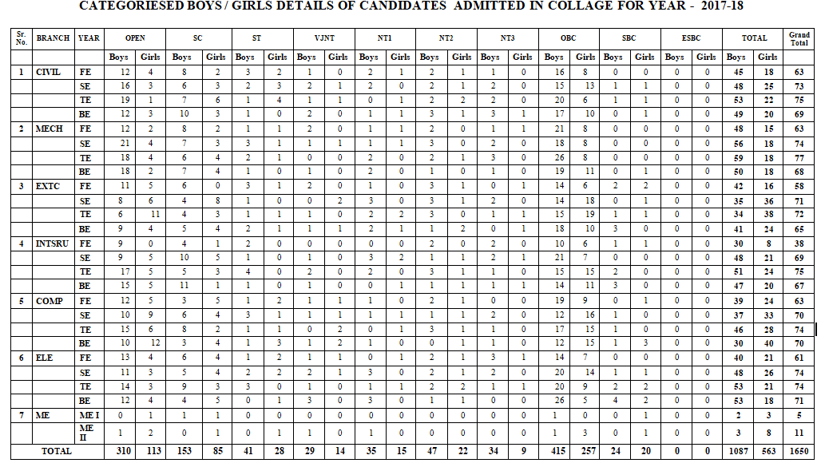

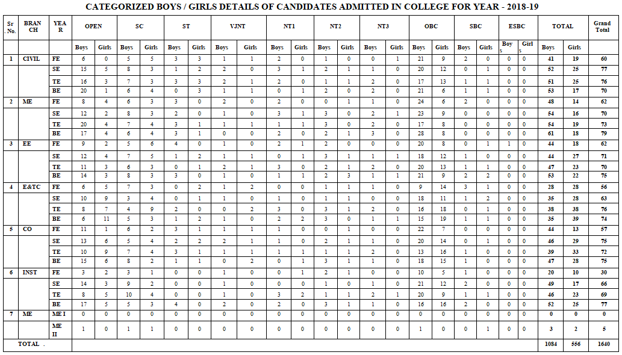

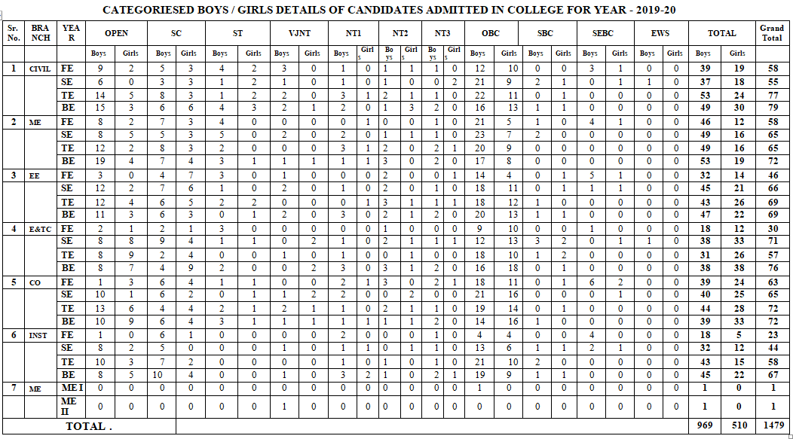

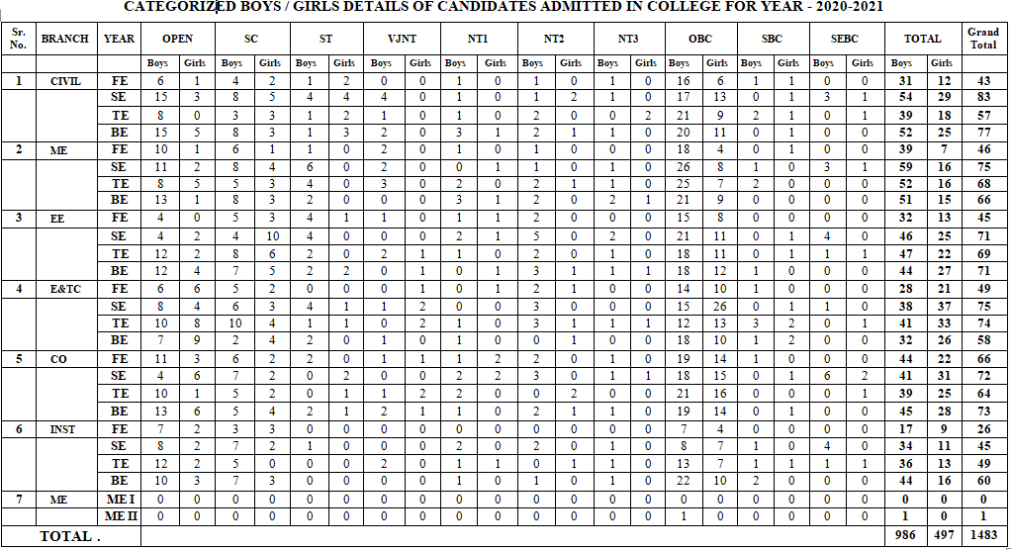

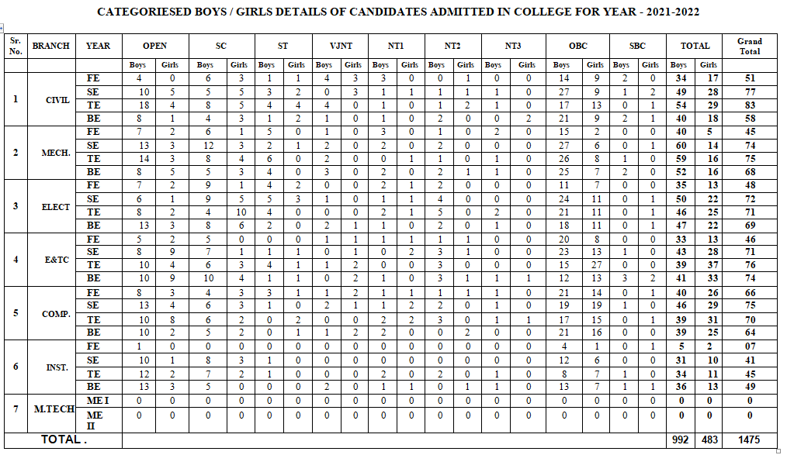

**2.5 Financial Matters:**

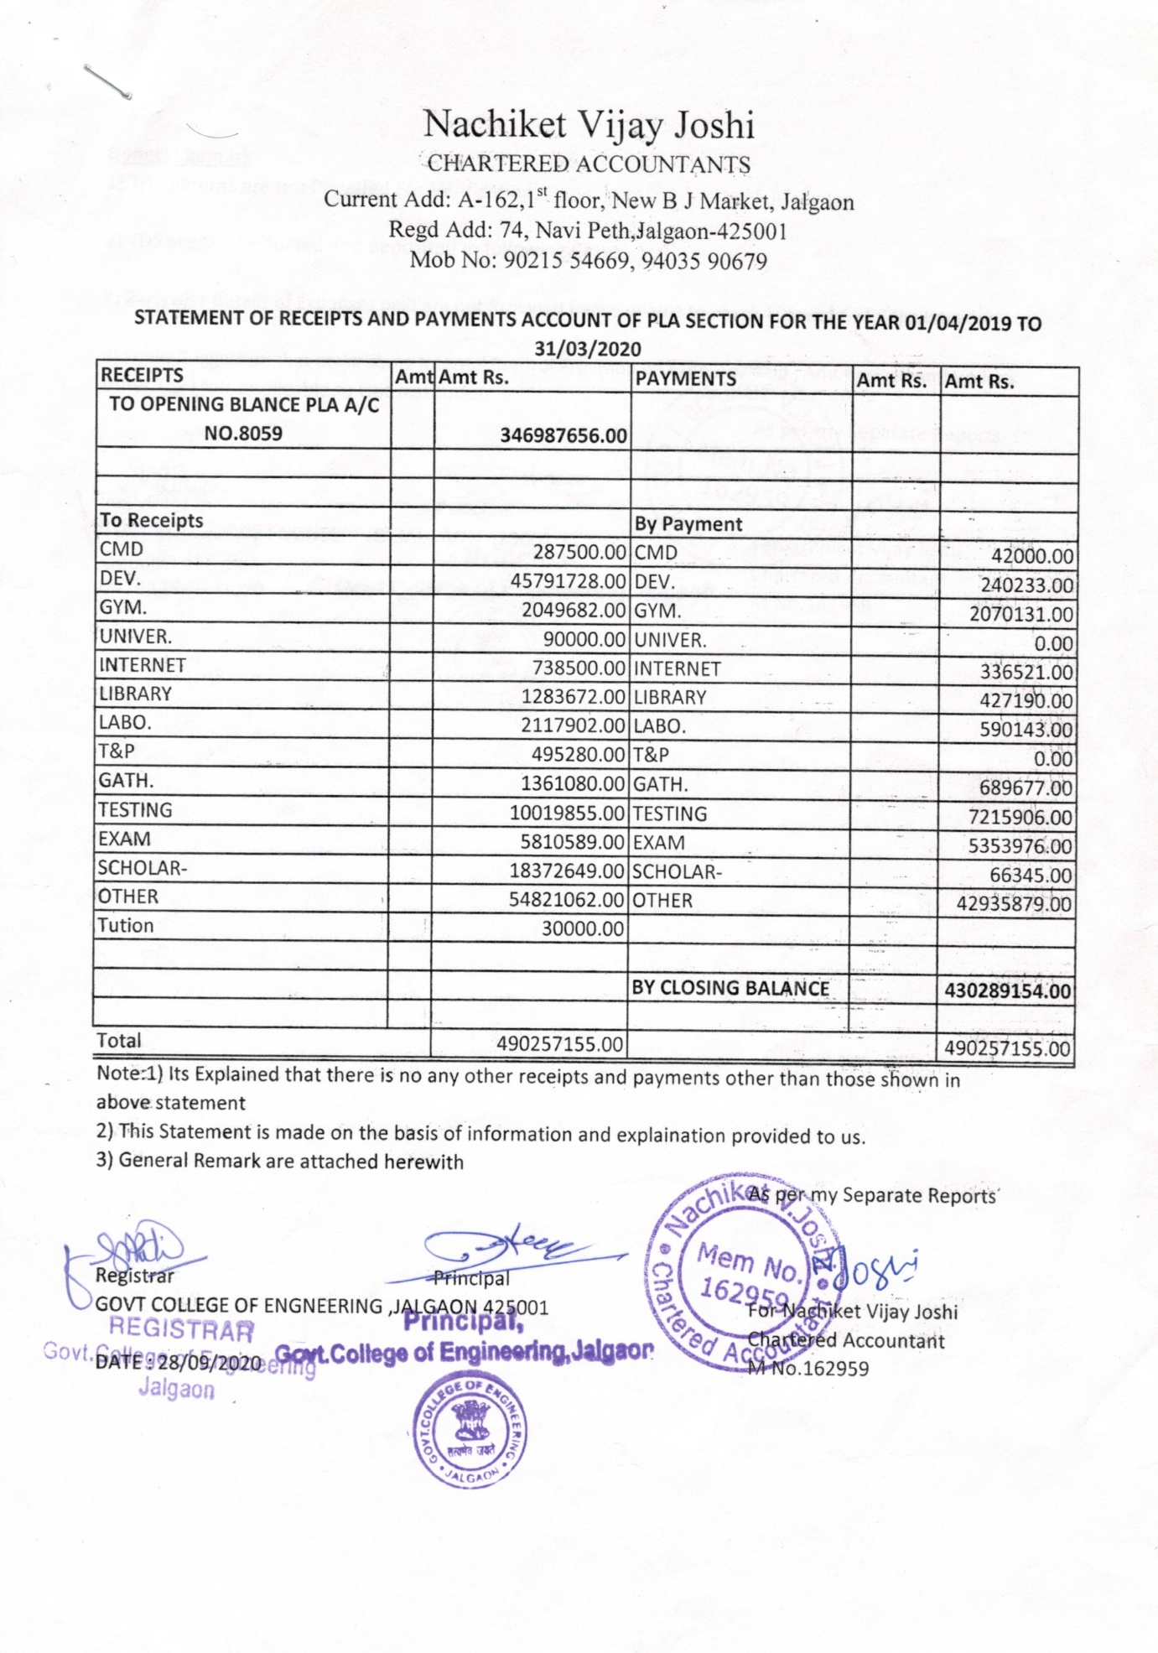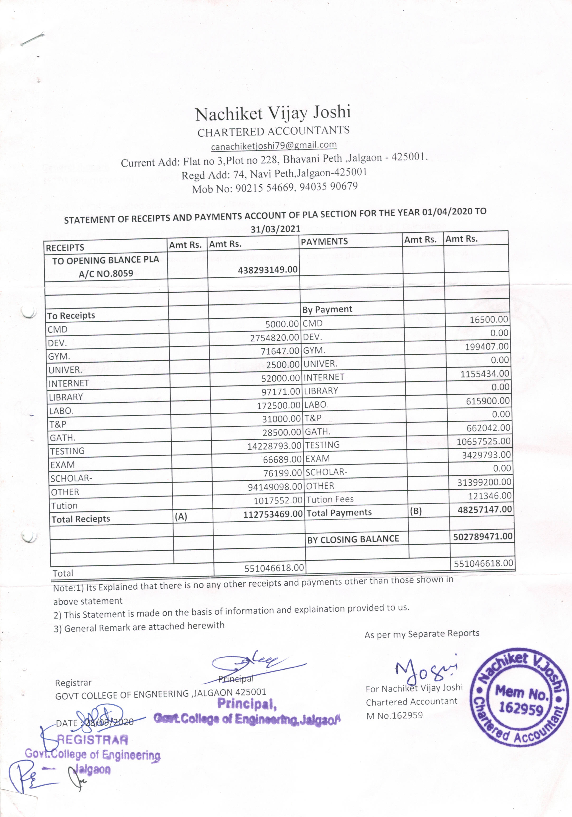

**3. Quality Assurance**

**3.1 Admission Statistics:**

**Regular Entry (F.Y. B. Tech.)**

|  |  |  |  |  |
| --- | --- | --- | --- | --- |
| **Sr. No.** | **Academic Year** | **Intake** | **Actual Admissions** | **Percentage of Admission** |
| 1 | 2020-21 | 360 | 275 | 76.38 |
| 2 | 2021-22 | 360 | 263 | 73.05 |
| 3 | 2022-23 | 360 | 329 | 91.38 |

**Lateral Entry (Direct Second year B. Tech.)**

|  |  |  |
| --- | --- | --- |
| **Sr. No.** | **Academic Year** | **Actual Admissions** |
| 1 | 2020-21 | 138 |
| 2 | 2021-22 | 138 |
| 3 | 2022-23 | 136 |

**3.2 Result Statistics (Branch-wise in percentage):**

|  |  |  |  |  |  |  |
| --- | --- | --- | --- | --- | --- | --- |
| **Academic  Year** | **ME** | **ET** | **IN** | **EE** | **CO** | **CE** |
| 2019-20 | 100 | 100 | 100 | 100 | 100 | 100 |
| 2020-21 | 98.48 | 100 | 100 | 98.59 | 100 | 98.7 |
| 2021-22 | 100 | 89.19 | 91.67 | 95.65 | 100 | 98.28 |

**3.3 Dropout Percentage:**

|  |  |  |
| --- | --- | --- |
| **Sr. No.** | **Academic year** | **Percentage** |
| 1 | 2019-20 | 5.04 |
| 2 | 2020-21 | 4.36 |
| 3 | 2021-22 | 1.90 |

**3.4 Placement Details**

* **Major recruiters participating in placement drive**

|  |  |
| --- | --- |
| **Sl. No.** | **Name of the Company** |
| 1 | Tata Consultancy Services |
| 2 | Santronix Pvt. Ltd, Jalgaon |
| 3 | Cerium Systems, Bangalore |
| 4 | Hexaware Technologies, Navi Mumbai |
| 5 | L-Cubes Innovation Solution. Pvt. Ltd, Pune |
| 6 | Casepoint. Pvt. Ltd, Surat |
| 7 | Sankey Solution Pvt. Ltd |
| 8 | Tudip Technologies Pvt. Ltd, Pune |
| 9 | Collabera Services, Vadodara |
| 10 | Torrent Power Limited, Mumbai |
| 11 | Qspider Pvt. ltd, Pune |
| 12 | Endress+Hauser flowtec Pvt. Ltd, Aurangabad |
| 13 | Thinkitive Technologies Pvt. Ltd |
| 14 | Mindtree(A Larsen & Toubro Group company), Pune |
| 15 | Mastersoft ERP Solution Pvt. Ltd, Nagpur |
| 16 | Inkey IT Solution Pvt. Ltd |
| 17 | NPAV Net Protector, Pune |
| 18 | Capgemini Pvt. Ltd, Pune |
| 19 | Accenture Pvt. Ltd |

* **Year-wise Placement Summary**

**2020- 21 Batch**

1. Maximum Package offered - **Rs. 4.5 lakhs** per annum

2. Average Package offered - **Rs. 2.5 lakhs** per annum

| Sr. No. | Branch | Total Students on Roll | Eligible Students | No. of Student Placed | GATE Qualified students | Total Placement | Percentage of Placement |
| --- | --- | --- | --- | --- | --- | --- | --- |
| 1 | Electronics & Tel. Engg. | 58 | 50 | 17 | 00 | 17 | 34% |
| 2 | Instrumentation Engg. | 60 | 55 | 13 | 01 | 14 | 25.45% |
| 3 | Mechanical Engg. | 66 | 60 | 22 | 05 | 27 | 45% |
| 4 | Computer Engg | 73 | 60 | 41 | 05 | 46 | 76.66% |
| 5 | Electrical Engg. | 71 | 60 | 14 | 01 | 15 | 25% |
| 6 | Civil Engg. | 77 | 60 | 02 | 10 | 12 | 20% |
|  | Total | 405 | 345 | 109 | 22 | 131 | 37.97% |

**2021- 22 Batch**

1. Maximum Compensation Package offered - **Rs. 17 lakhs** per annum

2. Average Compensation Package offered - **Rs. 3.5 lakhs** per annum

| Sr. No. | Branch | Total Student on Roll | Eligible Students | No. of Student Placed | GATE Qualified students | Total Placement | Percentage of Placement |
| --- | --- | --- | --- | --- | --- | --- | --- |
| 1 | Electronics & Tel. Engg. | 74 | 60 | 49 | 1 | 50 | 83.33 |
| 2 | Instrumentation Engg. | 49 | 40 | 31 | 1 | 32 | 80 |
| 3 | Mechanical Engg. | 68 | 60 | 41 | 2 | 43 | 71.66 |
| 4 | Computer Engg | 64 | 60 | 53 | 7 | 60 | 100 |
| 5 | Electrical Engg. | 69 | 60 | 36 | 3 | 39 | 65 |
| 6 | Civil Engg. | 58 | 50 | 08 | 6 | 14 | 40 |
|  | Total | 382 | 330 | 225 | 20 | 245 | 74.24 |

**3.5 Training Policy and Training Details**

**Training Policy**

Institute has a comprehensive training policy to maintain its reputation and ensure that its faculty and students are well-equipped to handle the latest trends and technologies. It includes various initiatives such as

1. Faculty are encouraged and deputed to attend seminars, workshops, conferences, and other training sessions.
2. Faculty and students are encouraged to enroll and register for NPTEL courses. Examination fee is reimbursed to students and faculty for successfully completed courses.
3. Soft skill and personality development training sessions are regularly arranged by Training and Placement Cell of the institute.
4. The institute has made a provision in the curriculum so that students undergo industrial training and internships.

**Training Details (No. of training programs completed by Faculty/Staff)**

|  |  |  |  |  |  |  |
| --- | --- | --- | --- | --- | --- | --- |
| **Academic  Year** | **ME** | **ET** | **IN** | **EE** | **CO** | **CE** |
| 2019-20 | 15 | 27 | 22 | 13 | 15 | 15 |
| 2020-21 | 17 | 6 | 19 | 1 | 25 | 10 |
| 2021-22 | 6 | 7 | 7 | 2 | 4 | 5 |

**3.6 Accreditation**

The institute is accredited by National Assessment and Accreditation Council, Bangalore, with the grade **B+**, for the period of 5 years and the period of accreditation is 30th November 2018 – 29th November 2023.

**3.7 Curriculum Development**

Institute strives hard to ensure the quality of graduates. Towards this, the institute has formed various statutory committees as per guidelines of the University Grants Commission, New Delhi. These committees include representatives of various stakeholders from academia and industry. After consultations with all stakeholders, the curriculum is revised every four years to meet industrial and social needs with multidisciplinary perspective.

**3.8 Autonomy**

The institute is affiliated to Kavayitri Bahinabai Chaudhari North Maharashtra University, Jalgaon, and has been granted academic autonomy since academic year 2014-15. Subsequently, an extension to the autonomy is granted to the institute in the academic year 2021-22.

**3.9 AICTE Grants**

AICTE has sanctioned the grant of 3 Crores for the construction of SC-ST - Girls Hostel and the work will be started in near future after getting necessary approvals and permissions from Government of Maharashtra.

**3.10 Energy Audit**

The institute had conducted electrical energy audit in the year 2020. The auditor has suggested replacing existing electrical set up by energy efficient set up.

**4. Institutional Development Proposal (IDP)**

**An Executive Summary of the IDP.**

The vision of the institution is “Globally Accepted Engineers with Human Skills”, which enlightens, empowers and enables the learners and ensures that the students are properly facilitated for global vision. The fundamental facilities are provided by the institute, but the institution is keen to see that the students have modern additional facilities such as additional academic infrastructure, accommodation facilities with more than 75% capacity for girls and boys, cafeteria, various clubs etc. In view of this, ffollowing are the key points for institutional development.

* Building Class Room Complex with the modern facilities
* Computer Centre Building with high-end computing facilities
* sports-arena and student activity center with sufficient infrastructure
* An auditorium of 1000+ capacities
* Modernization of Library
* The state of the art laboratories in each department
* Expansion of existing Hostels for girls and boys with capacity more than 75% of sanctioned intake in each

In this campus, innovative teaching methodologies are practiced in every stage to empower students. An assortment of committees and cells are functioning to empower the students like dyanmic Placement cell, Women Empowerment through Internal Complaint Committee-cum-Womens Grievance Cell (ICC) and Harassment-Anti Ragging prevention cell, Sports committee, Cultural committee, and Students welfare committee. The alumni of the institution have been instrumental in launching various programmes in the campus. All these cells are community oriented and provide opportunities for students to serve the society at large.

Another important initiative of the institution in this decade is to set up an e-library in support and collaboration with an institute of national importance to facilities so that both students and faculties/staff are provided with sufficient and modern facilities of e-books and e-journals. The library also recommended increasing the number of journals and renewing the subscriptions of previously subscribed journals (before Covid-19). The institution has plans to create functional subject-wise forums-cum-clubs in each of its departments, wherein every department is asked to conduct outreach programs like seminars, workshops, conferences at all levels and use the resources of both students and its faculty to benefit society at large. In addition to this, each department has asked to initiate multidisciplinary work so that the activity of the real work shall be initiated.

As per directions from Government of Maharashtra, Government of India, AICTE/DTE and University, all the Students are directed to complete the basic courses/case-studies related to rural areas and similar other environment related courses.

##### SWOT Analysis

**4.1.1 Methodology**

All the stakeholders of the institution [constituting the alumni, industries, teaching and non-teaching staff, students, parents, and society at large and public representatives] over a period of time have discussed various issues pertaining to the institute. The core committees headed by Institute Head, IQAC Committee, Academic and Examination Cell, Industry-Institute Interaction, and all stakeholders have arrived at the following SWOT analysis. The present methodology included and analyzed the following components-

* Information and data –Academic and Administrative

* Student opinions in the form of feedback and student meetings

*Institute-industry-alumni meeting and opinions in the form of feedback

Parents‐Teachers Meeting feedback



* Brainstorming by faculty

* Non-teaching staffs feedback

* All other stakeholders’ opinion

* **Strengths:**

Government College of Engineering Jalgaon (An Autonomous Institute of Government of Maharashtra), located in a city about 60 kms away from famous Ajanta Caves, is easily accessible by train from all over India such as Mumbai (5-8 Hrs), Delhi(15-20 Hrs) and other important places of the county. One of the important junctions of the Railway in Asia/India is Bhusawal Junction, which is just 25 km from Jalgaon. The population of the city constitutes the majority of OBC, ST, SC and other minority categories. It provides an ideal location to fulfill the college's mission of empowering students from backward and tribal areas. The strengths include:

**S1.** Healthy enrolment of Students

**S2.** Motivated faculty and Committed Staff

**S3**. Sufficient Own land in campus for further infrastructural development with support from

Technical Education Department(DTE)

**S4**. A Library that has reserved books for SC and ST students(book banks)

**S5**. Sports facilities for students and opportunities to participate in university/Regional/National level

**S6**. Permission and motivations to all for state, national and open tournaments, technical events

**S7**. Faculties are recruited by MPSC having uptomark overall abilities

**S8**. A supportive system encouraging participation in seminars, research activities and publications.

S9. Recognized KBC NMU reserach centers (PhD) in Civil, ElectricaL, E&TC, Instrumentation and Mechanical Engineering

**S10.** Student counseling and Student Grievance cell to address the needs of students

**S11**. Student Representative Council (SRC) in place to resolve issues of students at curricular, co-curricular and extra-curricular activities.

* **Weaknesses:**

**W1**. Lack of basic infrastructure, no separate buildings for UG/PG disciplines which were started after 2009. Therefore**,**  shortage of Classrooms and Laboratories (Classes/Labs are conducted as per possible resources)

**W2**. Infractural difficulties, in terms of auditorium for common activities, insufficient boys and girls hostels

**W3.** Acute shortage of permanent faculty particularly at all levels

**W4.** Institution‐ Industry interaction, Training and Placement linkages facing problem due to non existence of BoG

**W5**. Shortage of high computing Computers, limited Resources and facilities of

laboratories and lack of modernization of existing laboratories.

**W6**. Less Hostel accommodation capacity (For Boys and Girls).

**W7.** No rest rooms/common rooms for girls.

**W8.** Lacking for UGC 12(b) recognition

**W9.** No Gym for the students (Boys and Girls)

**W10.** Adverse effects of globalization, media & technology on the younger generation.

* **Opportunities:**

O1.Increasing enrollment of Girl students.

O2. More scope to provide quality higher education to rural students or students from

farmers family, workers family or from backward classes and tribal region.

O3. Possibility to Increase the innovation and research in rural areas and harness local

talents.

O4. Increasing enrolment of students belonging to the marginalized sections including SC,

ST and Minority groups.

O5. Tie-up opportunities with various Governmental organizations, industries and NGO s

O6. Establishing a Finishing school in various courses, add-on courses and self-employment

training.

O7. Offer post-graduate courses to cater the needs of industry.

O8. To obtain Unitary Technological University Status in the region.

* **Threats:**

T1. Increased dependence on semi-skilled Guest faculty and difficulty in motivating

students

T2. If the college does not get proper infrastructure and hostel facilities the students are   
 likely to move to private institutes nearby or cities like Nashik, Indore, Pune and

Mumbai.

T3. Lack of demand of multidisciplinary courses due to improper information to parents

and students.

T4. Unwillingness among the parents and alumni to participate in college developmental

activities.

T5. Ever growing Competitiveness in various Examinations and demanding eligibility

criteria for recruitment in various services.

T6. Limited space for infrastructural development.

#### 4.1.2 Strategic Plan for institutional development based on SWOT analysis

* + - * To introduce new short term and certificate courses for making education accessible to more women students from rural areas and less privileged sections of the society.
      * To enhance the quality of courses currently offered by making them more relevant, skill focused and responsive to the demands of the employment industry and to introduce Add-on courses to improve employability of the students.
      * To improve the current infrastructure similar to state of the art infrastructure with high computing machines and modern equipment.
      * To make the teaching learning process more effective by introducing smart classrooms, ICT integrated teaching and trained faculty in innovative teaching methodology.
      * To improve social responsibility and awareness in the students by pushing for more collaborative interaction between agencies working with a social concern
      * To introduce various clubs for technical development of the students such as BAE, Robocon-cum- Robotics and Control club, Drone club etc as well as to development of quality based cells in each department such as software development cell (SDC), Process and Computing (PAC) cell etc.
      * To establish various students' chapters by each department to have social and technical activities in each of the departments.
      * To improve infrastructure in terms of classroom complex, auditorium of 1000+ capacities, girls and boys hostels, boys and girls indoor gym.
      * To improve the facilities of indoor and outdoor sports by building necessary infrastructure and procurement of equipments.
      * To improve employability skills by soft-cum-aptitude training, training on various languages, training on technical and recent areas.
      * To establish a center of excellence in various fields.

#### 4.1.3 Specific Objectives and Expected Results Linked To The SWOT Analysis

| **SI.**  **No.** | **Specific objectives** | **Link to SWOT analysis** | **Expected Results** |
| --- | --- | --- | --- |
| 1 | To organize various events such as Science exhibition, project exhibition in or outside campus | S1, T3, | Greater access and equity in education, employment and opportunities for growth |
| 2 | To organize skill-based training, software and hands-on training | W6, W12, O3, T5, | Grater employability and provision for students to go on higher studies and  research |
| 3 | Soft-skills and aptitude training | W5, W7, T5, O6 | More number of students to be  employed |
| 4 | To arrange expert talks, industry talks, Workshops/STTP, student development programs | S1, S4, S6, W1, W2, W3, W11, O7, O8 | Quality education through better infrastructure |
| 5 | To establish center of excellence and various clubs | W5, W6, S8, S9, O2, O3 | Quality education through effective  teaching methodology |
| 6 | To organize technical, cultural and sports events | S5,W11,O3, O5 | Social responsibility, civic awareness and self-reliance among students |
| 7 | To arrange sessions on brainstorming, STTP / FDP/ Workshops, industry training | S2, S8, O3, O5, O8, W4, W10 | Better equipped faculty promoting quality education |
| 8 | To automate official procedures through MIS and digitization | S2, W6, O8 | e- governance promoting accuracy  and efficiency |

##### 4.2 Action plan for Development:

1. **Improving employability of graduates:** The institution has plans to train students in various employability skills like

* learning Basic English grammar, personality development, Communication skills in English, learning of foreign language.
* Certificate courses in Computer application or related fields , hardware and software development, improving the skills in multidisciplinary or similar areas
* Soft skills, leadership skills and inter-personality development
* Basic information and habits to solve routine problems ,Entrepreneurial skills and interpersonal skills in connection with startups and other development activities.
* Skills in traditional knowledge and self-employment,
* Entering into collaborative arrangements with outside bodies /experts for employment oriented value addition courses, new teaching learning methodologies and innovations
* developing new methods of formative and internal evaluation for improving teaching learning process as per advice from experts
* motivating and counseling to the students for industry training, internship, industry collaborative projects.
* Guidance and counseling through experts for competitive examinations, GATE examinations, UPSC/MPSC etc examination
* **Short term courses.**

There are also plans to develop capacity development projects for students so that their employability is increased through add on courses, certificate courses, workshops, seminars etc., Teachers and Students are encouraged to take up research projects and innovative projects, consultancy and testing works

##### Time activity chart (2022-23 onwards from First Year to Final Year)

| **Sl no.** | **Domain** | **Time**  **(In Hours)** | **2022-23 (First Year)** | **2023-24 (Second Year)** | | | | **2024-25(Third Year)** | | | | **2025-26 onwards** | | | |
| --- | --- | --- | --- | --- | --- | --- | --- | --- | --- | --- | --- | --- | --- | --- | --- |
| **Q 1** | **Q 2** | **Q 3** | **Q 4** | **Q1** | **Q 2** | **Q3** | **Q 4** | **Q 1** | **Q 2** | **Q 3** | **Q 4** |
| **1** | General aptitude | **30** | **Initiate** |  |  |  |  |  |  |  |  |  |  |  |  |
| Additional skills | **12** | **-//-** |  |  |  |  |  |  |  |  |  |  |  |  |
| Mental ability | **12** |  |  |  |  |  |  |  |  |  |  |  |  |  |
| **2** | **SELF EMPLOYABILITY cum-startup training** | **30** | -//- |  |  |  |  |  |  |  |  |  |  |  |  |
| Self Development  course | **10** | **-//-** |  |  |  |  |  |  |  |  |  |  |  |  |
| computer  software training | **40** | **-//-** |  |  |  |  |  |  |  |  |  |  |  |  |
| leadership course | **20** |  |  |  |  |  |  |  |  |  |  |  |  |  |
| **3** | **LIFE SKILLS**  Soft skills and personality development. | **30** | **-//-** |  |  |  |  |  |  |  |  |  |  |  |  |
| Practice(by Own) | **-** | **-//-** |  |  |  |  |  |  |  |  |  |  |  |  |

* + - * self practices and coaching on competitive exam preparation by themselves

##### Action plan with budgetary allocation* (2022-2034)

| **Sl. No** | **Employability Programmes** | **Budget Allocation in lakhs**  **(All disciplines / branches)** | | **Total Budget in lakhs** |
| --- | --- | --- | --- | --- |
| **2022-23 to 2027-28** | **2028-29 to 2033-34** |
| 1 | Competitive exams | 15/year | 20/year | **35/year** |
| 2 | Certificate course | 24/year | 30/year | **54/year** |
| 3 | GATE and Life skill Training. | 18/year | 25/year | **43/year** |
| 4 | Employability Skill development | 25/year | 35/year | **60/year** |
|  | **Total** | **82/year** | **110/year** | **192/year** |

* The proposed budget is tentative and may be transferable for various student trainings.

1. **Increased learning outcomes of the students**:

In order to increase the learning outcomes of the students, the institution has directed all the departments to adapt all measures to improve the results like taking remedial classes for slow learners and taking the help of advanced learners to assist the slow learners as well as the all the professional teaching members are recommended to conduct additional classes for the students for slow learners. Motivational classes are conducted to increase an urge to complete their courses. All the departments are recommended and suggested to increase the expert talks-cum- sessions from the persons of repute either he/she in industry or public sectors.

Following activities are undertaken to enhance learning outcomes of the students:

* Courses and training to develop life skills, learning abilities and long learning and employability related learning.
* Employability skills training should be organized through various departments/TPO cell.
* Academic as well as other skills through tutorial and other means.
* Promotes cultural skills through extracurricular activities
* Field surveys, Industrial visits and study tours will be conducted regularly.
* Project works, periodical seminars, workshops, special lectures, group discussions will be arranged.
* The modern pedagogical tools are effective learning. Modern ICT is being used more and more to make the learning experience more effective.

##### Time activity chart (per year per class)

| **Sl no.** | **Domain** | **Time required** | **2022-23 (FY)** | | | | **2023-24 (SY)** | | | | **2024-25 (TY)** | | | | **2025-26 (Final Year)** | | | |
| --- | --- | --- | --- | --- | --- | --- | --- | --- | --- | --- | --- | --- | --- | --- | --- | --- | --- | --- |
| **Q 1** | **Q 2** | **Q 3** | **Q 4** | **Q 1** | **Q 2** | **Q 3** | **Q 4** | **Q 1** | **Q 2** | **Q 3** | **Q 4** |  |  |  |  |
| **1** | **Motivational** | 12 Hrs |  |  |  |  |  |  |  |  |  |  |  |  |  |  |  |  |
| **2** | **Educational tours** | 1week |  |  |  |  |  |  |  |  |  |  |  |  |  |  |  |  |
| **3** | **ICT education** | 18-24 Hrs |  |  |  |  |  |  |  |  |  |  |  |  |  |  |  |  |
| **4** | **Spoken English** | 30 Hrs |  |  |  |  |  |  |  |  |  |  |  |  |  |  |  |  |
| **5** | **Projects** | 3 months |  |  |  |  |  |  |  |  |  |  |  |  |  |  |  |  |
| **6** | **Seminars and**  **workshops** | 1 week |  |  |  |  |  |  |  |  |  |  |  |  |  |  |  |  |

**Budget allocation chart for attainment of learning outcomes**

| **Sl. No** | **Employability Programmes** | **Budget Allocation in lakhs** | | | | **Total Budget in lakhs (Activity wise)** |
| --- | --- | --- | --- | --- | --- | --- |
| **FY** |  | **TY** | **Final Year** |
| **1** | **Motivational** | 2 | 2 | 2 | 1 | **7** |
| 2 | Educational tours | 5 | 5 | 5 | 5 | **20** |
| 3 | ICT education | 2 | 2 | 2 | 2 | **8** |
| 4 | Spoken English | 5 | 5 | 5 | 5 | **20** |
| 5 | Projects | 1 | 2 | 4 | 6 | **13** |
| 6 | Seminars and workshops | 1 | 6.5 | 8 | 6.5 | **22** |
|  | **Total (Class wise)** | **16** | **22.5** | **26** | **25.5** | **90** |

1. **Obtaining Unitary status by 2032-33:**

The institution has received 2(f) status and permanent affiliation to the 50% UG courses from the affiliating university. The institute will try to fulfill the conditions to obtain 12(B) status and for the same correspondence with the UGC will be made by 2025. The institution has been accredited by NAAC with B+ Grade (2.67 CGPA). The institute is in the process to get A grade after fulfilling the necessary and sufficient conditions. After getting 12(B) status, further process will be made to get unitary technological university

##### Achieving the targets of Accreditation

Two (2) UG Programs of the institute were re-accredited by NBA for the year 2018-2021 and further efforts will be made for accreditation of the other programs after fulfillment of the condition of student-faculty-ratio (SFR) and other [infrastructure](https://www.google.co.in/search?q=infrastructure&spell=1&sa=X&ved=2ahUKEwi5tqf4vs36AhWT0nMBHXDAC_AQkeECKAB6BAgGEAE). The Institute will be providing necessary facilities to get NAAC accreditation with A grade in cycle 2 by 2023. Achievement of future targets will take place as per strategic planning at the institute and Government level.

##### Implementation of Academic and Non-academic reforms:

The Institute is autonomous and affiliated to KBC North Maharashtra University. As the institute is of Government of Maharashtra, all the admission process is highly transparent. The admissions are done in accordance with the set norms, rules and regulations laid down by the CET cell of The Government of Maharashtra. The CET cell conducts Examination for all the eligible students and all the seats are filled through the CAP rounds. The vacant seats are filled at institute level by following all the norms and publishing vacancy positions on institute websites with advertisements in various newspapers. In CAP as well as non-CAP rounds, Reservation provisions are followed strictly as per norms.

An action plan is needed for the phase-wise introduction of substantive academic reforms in the institutions of higher education in the country. Academic reforms are a key towards imparting better quality education that is oriented towards employability, start-up and innovation. In addition to changes in the existing system, this institute needs to introduce new policies that would make the higher education system more flexible to the needs of the students and the society.

The orientation-cum-induction program will be conducted at the beginning of academic year and information with regard to various processes like admission, examination, evaluation, library, co-curricular and extracurricular activities, and fee structure and healthy practices of the college are given to the students. This institute is in process to start NSS activities from 2022-23. The key parameters include

* · Implementing academic reforms like curricular, evaluation methods, feedback mechanism etc.
* Continuous Internal evaluation will be implemented and students will be monitored regularly to get good command over Courses and results.
* Executing/establishment of BOG/BOM/ Governing Body/Financial Committee/ BoS/APEC//EC etc management-cum-policy related committees, recruitment under autonomy either on contract or as per decision of GoM,
* Procurement reforms and maintenance of laboratories and other related activities.

##### Time activity chart(UG)

| **Sl no.** | **Domain** | **Time required** | **First Year** | | | | **Second Year** | | | | **Third Year** | | | | **Final Year** | | | |
| --- | --- | --- | --- | --- | --- | --- | --- | --- | --- | --- | --- | --- | --- | --- | --- | --- | --- | --- |
| **Q 1** | **Q 2** | **Q 3** | **Q 4** | **Q 1** | **Q 2** | **Q 3** | **Q 4** | **Q 1** | **Q 2** | **Q 3** | **Q 4** | **Q 1** | **Q 2** | **Q 3** | **Q** |
| **1** | **Orientation/Induction programs** | 2 weeks |  |  |  |  |  |  |  |  |  |  |  |  |  |  |  |  |
| **2** | **Motivational** | 1week |  |  |  |  |  |  |  |  |  |  |  |  |  |  |  |  |
| **3** | **Workshops** | 1 week |  |  |  |  |  |  |  |  |  |  |  |  |  |  |  |  |
| **4.** | **Startup/ innovation** | 1 week |  |  |  |  |  |  |  |  |  |  |  |  |  |  |  |  |

**Learning outcome budget allocation chart(For Academic Year 2022-23)**

| **Sl. No.** | **Employability Programmes** | **Budget Allocation in Lakhs** | | | | **PG/ PhD** | **Total**  **(Lakhs)** |
| --- | --- | --- | --- | --- | --- | --- | --- |
| **2022-23 (FY)** | **SY** | **TY** | **B.Tech** |
| **1** | **Orientation/ Induction programs** | 2.0 | 1.0 | 0.5 | 0.5 | 0.25 | **4.25** |
| **2** | **Motivational** | – | 0.5 | 1.0 | 0.5 | 0.25 | **2.25** |
| **3** | **Workshops** | 0.5 | 1.2 | 1.2 | 1.2 | 0.5 | **4.6** |
| **4** | **Startup/ innovation** | 1.0 | 1.2 | 2.4 | 4.8 | 0.6 | **10.0** |
|  | **Total** | **3.5** | **3.9** | **5.1** | **7.0** | **1.6** | **21.1** |

1. **Improving interaction with industry:**

The institution has signed MoU with some of the industries and plans to sign MOU with other industries for internship, research, training and employing the students. The key parameters include

* Students are encouraged to collect data of industry’s functioning in the area.·
* Continuous Internal evaluation will be implemented and students will be monitored regularly to get good command over Courses and results.
* Inviting experts from industry for special lectures
* Promoting student for taking industrial projects
* Enhancing industrial visits where the students are placed to get better interaction
* Improving Alumni Connect program
* Promote collaborative interdisciplinary work, consultancy, testing, research.
* Improving support of nearby and local industries

##### Time activity chart

| **Sl no.** | **Domain** | **Time required In months** | **2022-23** | | | | **2023-24** | | | | **2024-25** | | | | **2025-26** | | | |
| --- | --- | --- | --- | --- | --- | --- | --- | --- | --- | --- | --- | --- | --- | --- | --- | --- | --- | --- |
| **Q 1** | **Q 2** | **Q 3** | **Q 4** | **Q 1** | **Q 2** | **Q 3** | **Q 4** | **Q 1** | **Q 2** | **Q 3** | **Q 4** | **Q 1** | **Q 2** | **Q 3** | **Q 4** |
| **1** | **Add-on course to**  **suit industry** | 1-3 months |  |  |  |  |  |  |  |  |  |  |  |  |  |  |  |  |
| **2** | **Industrial visit** | 1week |  |  |  |  |  |  |  |  |  |  |  |  |  |  |  |  |
| **3** | **Arranging lectures**  **from industrial experts** | 1 week |  |  |  |  |  |  |  |  |  |  |  |  |  |  |  |  |
| **4** | **Projects with the**  **local industry** | 1-3 months |  |  |  |  |  |  |  |  |  |  |  |  |  |  |  |  |

**Improving interaction with industry budget allocation chart**

| **Sl. No** | **Activities** | **Budget Allocation (Lakhs)** | | | | **Total Budget in lakhs** |
| --- | --- | --- | --- | --- | --- | --- |
| **2022-23** | **2023-24** | **2024-25** | **2025-26** |
| 1 | Add-on course to suit Emerging Technology | 30.0 | 32.0 | 34.0 | 40.0 | **136.0** |
| 2 | Industrial visit | 5.0 | 8.0 | 9.0 | 10.0 | **32.0** |
| 3 | Arranging lectures from industrial experts | 12.0 | 12.0 | 14.0 | 15.0 | **53.0** |
| 4 | Projects with the local industry | 6.5 | 7.0 | 8.0 | 9.0 | **30.5** |
|  | **Total** | **53.5** | **59.0** | **65.0** | **74.0** | **251.5** |

1. **Enhancement of Research and Consultancy Activities**

A functioning research and innovative cell will be setting up in the institution to

* + Plans and executes seminars and workshops to provide information about research methods, innovation concepts and techniques to both students and teachers.
  + Upgrade library and laboratory to meet research requirement
  + To develop networks with other Universities/organizations for faculty and student exchange programs. In the First phase, faculty exchange will be carried out in institutes of Government of Maharashtra/India.
  + The budgetary allocation will be made accordingly to those who are visiting the campus in Jalgaon under faculty exchange program. The facilities and remuneration of faculty exchange will be the same as KBC North Maharashtra University Jalgaon as approved in the council and/or senate of University.
  + The exchange of the students for one or two semesters will be made as per the decision of the mutual institute. In the First phase, the students exchange program will be carried out in institutes of Government of Maharashtra(Government or Government aided in similar disciplines)/India.
  + Promotion of research and entrepreneurial activities in multidisciplinary areas
  + To provide consultancy services in technological fields, teaching and learning, basic and advanced computer science, basic and advanced training in skill based areas, basic and advanced training in multidisciplinary and engineering education, training in high computing areas etc.
  + Promote industry-academia-alumni partnerships
  + Focus on improving present technologies, developing indigenous ones and enhancing production and productivity.

##### Time activity chart

| **Sl no.** | **Domain** | **Time required In months** | **2022-23** | | | | **2023-24** | | | | **2024-25** | | | | **2025-26** | | | |
| --- | --- | --- | --- | --- | --- | --- | --- | --- | --- | --- | --- | --- | --- | --- | --- | --- | --- | --- |
| **Q 1** | **Q 2** | **Q 3** | **Q 4** | **Q 1** | **Q 2** | **Q 3** | **Q 4** | **Q 1** | **Q 2** | **Q 3** | **Q 4** | **Q 1** | **Q 2** | **Q 3** | **Q 4** |
| **1** | **Subscribing to e-journals and**  **journals** | 3 months |  |  |  |  |  |  |  |  |  |  |  |  |  |  |  |  |
| **2** | **Setting Up of**  **research centre** | 6 months |  |  |  |  |  |  |  |  |  |  |  |  |  |  |  |  |
| **3** | **Arranging lectures, seminars and workshop for**  **teachers** | 3 months |  |  |  |  |  |  |  |  |  |  |  |  |  |  |  |  |

**Improving interaction with industry budget allocation chart**

| **Sl. No** | **Programmes** | **Budget Allocation in lakhs** | | | | **Total Budget in lakhs** |
| --- | --- | --- | --- | --- | --- | --- |
| **2022-23** | **2023-24** | **2024-25** | **2025-26** |
| 1 | Subscribing to e-journals and  journals | 15 | 15 | 15 | 15 | **60** |
| 2 | Setting Up research center | 200 | 300 | 400 | 200 | **1100** |
| 3 | Arranging lectures, seminars and workshop for  teachers | 10 | 12 | 14 | 15 | **51** |
|  | **Total** | **225** | **327** | **429** | **230** | **1211** |

**4.3 Action Plan For Finishing School For SC/ST/OBC and improving performance of academically**

**Weak Students and SC/ST, OBC/SBC, VJ-NT/EWS**

(Through innovative methods, such as remedial and skill development classes for increasing the transition rate and pass rate with the objective of improving their employability)

* + - * Identify weak students
      * Remedial Coaching for SC/ST / **OBC/SBC, VJNT/EWS/PWA**  & Minorities.
      * Coaching for GATE/UPSC/MPSC/ for SC / ST/ OBC/VJNT, PWA & Minorities.
      * Coaching Classes for competitive exams to SC/ST / OBC & Minorities.
      * Career & Counseling Cell (CCC).
      * Personal interview techniques and special coaching.
      * Identify skill gaps, and develop industry specific skills, and increase brainstorming

sessions for self-awareness and self-analysis.

##### Action Plan

| **Sl no.** | **Programmes** | **Time in months** | **2022-23** | | | | **2023-24** | | | | **2024-25-** | | | | **2025-26** | | | |
| --- | --- | --- | --- | --- | --- | --- | --- | --- | --- | --- | --- | --- | --- | --- | --- | --- | --- | --- |
| **Q 1** | **Q 2** | **Q 3** | **Q 4** | **Q 1** | **Q 2** | **Q 3** | **Q 4** | **Q 1** | **Q 2** | **Q 3** | **Q 4** | **Q 1** | **Q 2** | **Q 3** | **Q 4** |
| **1** | **Remedial class** | 1 months |  |  |  |  |  |  |  |  |  |  |  |  |  |  |  |  |
| **2** | **Soft skill training** | 3 months |  |  |  |  |  |  |  |  |  |  |  |  |  |  |  |  |
| **3** | **Motivational** | 3 months |  |  |  |  |  |  |  |  |  |  |  |  |  |  |  |  |
| **4** | **Training for**  **competitive exams** | 6 months |  |  |  |  |  |  |  |  |  |  |  |  |  |  |  |  |
| **5** | **Coaching for**  **GATE exam** | 3 months |  |  |  |  |  |  |  |  |  |  |  |  |  |  |  |  |

**Budget allocation Plan**

| **Sl. No** | **Programmes** | **#Budget Allocation in lakhs per students** | | | | **Total Budget in lakhs** |
| --- | --- | --- | --- | --- | --- | --- |
| **2022-23** | **2023-24** | **2024-25** | **2025-26** |
| **1** | **Remedial class** | 2 | 2 | 4 | 5 | **13** |
| **2** | **Soft skill training** | 20 | 25 | 25 | 30 | **100** |
| **3** | **Motivational** | 5 | 5 | 6 | 7 | **23** |
| **4** | **Training for competitive exams** | 10 | 12 | 14 | 16 | **52** |
| **5** | **Coaching for GATE exam** | 12 | 14 | 16 | 18 | **60** |
|  | **Total** | **49** | **58** | **65** | **76** | **248** |

##### 4.4 Action plan for strengthening of PG/PhD programs and starting of new PG/PhD programs.

The following measures will be taken to improve the standards of PG/PhD programs.

* + - * Efforts will be made to improve the needs of computational and multidisciplinary facility
      * Subject experts and trained man power with improved infrastructure to start new PG courses like M. Tech in Computer Science and Engineering, M. Tech Civil Engineering, M. Tech Artificial Intelligence and Data Science, M. Tech in Cyber Security and other similar programs in various disciplines.
      * Adequate infrastructure and an independent computer and foreign language laboratory will

be made.

* + - * Smart class rooms with interactive panels will be used for environmentally friendly education.
      * Arrange more campus drives for PG/PhD students.

| **Key activities** | **Time period** |
| --- | --- |
| Meet the UGC 12(B) Status | 4 Years |
| Introduce and strengthen new PG courses | 24 months |
| Obtain experienced and qualified faculty in relevant  subject areas | Contract faculty direct or through agency will be recruited(If permitted by GoM) |
| Curriculum and syllabus design, development and  associated tasks | Continuous activity |

##### 4.5 Summary of Training Needs Analysis Carried out (TNA)

Institutional plans to spend at least 50% institutional consultancy/IRG on faculty and staff development in these following areas.

* + - * Basic and advanced Pedagogy.
      * Up gradation of qualifications.
      * Improving competence in teaching and training.
      * Development of modern learning resources and teaching aids
      * Training on AICTE, UGC, NBA, NAAC and University related activities
      * New techniques in research, improving competence in research and consultancy.
      * Deputation to seminars, conferences and presentation of research papers.
      * Establishing linkages with academic and research institutions and industry, Studen counseling.

##### Action Plan

| **Sl no.** | **Nature of Training** | **No Staffs** | **Time in months** | **2022-23** | | | | **2023-24** | | | | **2024-25** | | | | **2025-26** | | | |
| --- | --- | --- | --- | --- | --- | --- | --- | --- | --- | --- | --- | --- | --- | --- | --- | --- | --- | --- | --- |
| **Q 1** | **Q 2** | **Q 3** | **Q 4** | **Q 1** | **Q 2** | **Q 3** | **Q 4** | **Q 1** | **Q 2** | **Q 3** | **Q 4** | **Q 1** | **Q 2** | **Q 3** | **Q 4** |
| **1** | Basic & Advanced Pedagogy training  to all faculty | 24 | 0.5 |  |  |  |  |  |  |  |  |  |  |  |  |  |  |  |  |
| **2** | Subject and domain Knowledge  Enhancement | 24 | 0.5 |  |  |  |  |  |  |  |  |  |  |  |  |  |  |  |  |
| **3** | Attendance in activities such as workshops and  seminars | 24 | 1 week |  |  |  |  |  |  |  |  |  |  |  |  |  |  |  |  |
| **4** | Improvement in  faculty qualifications  (post PhD) | 24 | 6-24 |  |  |  |  |  |  |  |  |  |  |  |  |  |  |  |  |
| **5** | Improving  research capabilities/ Industry Training | 24 | 1-3 |  |  |  |  |  |  |  |  |  |  |  |  |  |  |  |  |

**Budget Allocation chart**

| **I** |  | **Short Term Training** | | | **Medium Term Training** | | | **Long Term Training** | | |
| --- | --- | --- | --- | --- | --- | --- | --- | --- | --- | --- |
| Sl.  No. | Name of Training | Number of Days | Number of faculty | Rate per Faculty Member | Number of Days/ Months | Number of Faculty | Rate per Faculty Member | No. of Years | No. of Faculty Members | Rate per Faculty Member |
| 1 | Basic Pedagogy | 2 | 24 | 4000 | 20 days | 24 | 13000 |  |  |  |
| 2 | Advanced  Pedagogy | 6 | 24 | 6000 | 21 days | 24 | 13000 |  |  |  |
| 3 | Subject/Domain  Knowledge | 6 | 24 | 4000 | 21 days | 24 | 13000 | 1 year | 24 | 100000 |
| 4 | ICT Training | 6 | 40 | 2500 | 1  month | 40 | 50000 |  |  |  |
| 5 | Research  Methodology | 2 | 24 | 2500 | 0.5-1  month | 24 | 10000 |  |  |  |
| 6 | Administrative  training | 6 | 40 | 5000 | 2 weeks | 40 | 50000 | 1 year | 3 | 100000 |
|  | Total |  |  | 24000 |  |  | 149000 |  |  | 200000 |
|  |  |  |  |  |  |  |  |  | **Grand**  **Total** | **373000** |

**4.6 Action plan for Training and Technical and other staff in functional areas.**

* + - * Update new skills and competencies to handle new laboratory instruments and equipment.
      * Library digitization and Developments in library sciences,
      * Recent developments in the science of sports ,
      * Motivate the staff for training and to enhance administrative staff development training programs on Modern office equipment, Software, Office automation, Maintenance of records, Procedures and Friendliness towards faculty and students.

##### Action Plan

| **Sl no.** | **Department/ Section** | **No Staffs** | **Time in months** | **2022-23** | | | | **2023-24** | | | | **2024-25** | | | | **2025-26** | | | |
| --- | --- | --- | --- | --- | --- | --- | --- | --- | --- | --- | --- | --- | --- | --- | --- | --- | --- | --- | --- |
| **Nature of**  **Training** | **Q 1** | **Q 2** | **Q 3** | **Q 4** | **Q 1** | **Q 2** | **Q 3** | **Q 4** | **Q 1** | **Q 2** | **Q 3** | **Q 4** | **Q 1** | **Q 2** | **Q 3** | **Q 4** |
| **1** | **Library** | 1 | 0.5-3 |  |  |  |  |  |  |  |  |  |  |  |  |  |  |  |  |
| Library digitization and  automation |  |  |  |
| **2** | **Physical /Sports Education** | 1 | 0.5-3 |  |  |  |  |  |  |  |  |  |  |  |  |  |  |  |  |
| Recent developments in the science of  sports |  |  |  |
| **3** | **All Office staffs** | 16 | 0.5-3 |  |  |  |  |  |  |  |  |  |  |  |  |  |  |  |  |
| Office Automation and  Computer |  |  |  |
| **4** | **All office and Teaching Staff** | 40 | 0.5-3 |  |  |  |  |  |  |  |  |  |  |  |  |  |  |  |  |
| RTI/TPO/AEC  Office Procedure |  |  |  |

| **Sl. No.** | **Training** | **Budget Allocation in lakhs** | | | | **Total Budget in lakhs** |
| --- | --- | --- | --- | --- | --- | --- |
| **2022-23** | **2023-24** | **2024-25** | **2025-26** |
| **1** | Library digitization  and automation | 50 | 50 | 40 | 40 | **702** |
| **2** | Recent developments in the  sports and extracurricular activities | 100 | 100 | 100 | 100 |
| **3** | Training on UGC and University Act | 3 | 3 | 3 | 5 |
| **4** | Office Automation and Computer | 30 | 25 | 25 | 20 |
| **5** | RTI/ TPO /AEC  Office Procedure | 2 | 2 | 2 | 2 |
|  | **Total** | **185** | **180** | **170** | **167** |

* 1. **Relevance and coherence of IDP with States/National industrial Economic Development Plan.**
* Need for quality achievement, providing infrastructural support and modernizing administration as the primary concerns
* The objective of the proposals should cater to the requirement of the State so that the inputs of the institution could benefit the region.
* It should confirm the Government objective of higher education to improve GER and align with the States and Regional economic development plan.
* Achieving social justice and social equity through higher education
* Empowering students to become responsible citizens
* Empowering women and the marginalized through higher education

##### 4.8 Participation of departments / faculty in the IDP preparation.

Action plan is prepared for the proper coordination with faculties of various departments. A proper integrated and co-ordination mechanism with different committees will be made. The steps involved in arriving at the proposal are as follows.

* A brainstorming session organized by IQAC to conduct the SWOT analysis.
* Student feedback constitutes a crucial component in the SWOT analysis.
* Having identified the key areas, objectives for the Institutional Plan arrived at in discussion with the faculty
* Inputs from departments of library and physical education sought to prepare the plan.
* Administrative staff support sought at specific junctures during the preparation of the plan.

##### 4.9 Institutional Project implementation arrangements with participation of faculty and staff.

Based on the analysis and discussions with the core committee and other members, Institutional level bodies will be formed and the project responsibilities will be assigned to each body. The detailed functions of each body are as below.

##### Board of Governors (BoG)(At this stage BoG is not in place for this institute). But after getting BoG, functions will be

* Take all policy decisions of the institute
* Take all the financial decision of institute for the improvement of students skills and placements
* Take all the decisions for the contract appointment of the highly qualified (PhD) and experienced faculties. Decide the salary as per norms of Government of Maharashtra
* Form and supervise and Guide various committees,
* Ensure proper utilization of funds and timely audit of the same.
* Monitor progress with transparency.
* Make policy decisions in line with NEP-2020.
* Support to improve startup in and incubation in institute
* Support for the short term and long term goal of the institute.
* Make and support other activities for the benefit of all the stakeholders.

##### Board of Governors

The BoG of this institute is dissolved in 2019 by Government of Maharashtra through it’s Resolution No. MISC-1111/(02/20)/TE-2,Dt.10/01/2020

### 

1. **Action Plan (With Budget)**

| Sl. No. | Objective | Necessary Action | Institute Level Action | Government Level Action | Proposed Allocation (Rs in Crores) | Planning Period | | | | |
| --- | --- | --- | --- | --- | --- | --- | --- | --- | --- | --- |
| 23-24 | 24-25 | 25-26 | 26-27 | 27-28 |
| A | **Infrastructure Development** |  |  |  | **124.13** | **25.4** | **27.9** | **27.73** | **21.6** | **19.5** |
|  | 1.Construction of UG and PG Class Rooms (Class room Complex) | 1. Proposal Preparation, plan selection and finalization in communication with PWD  2. Estimate preparation by PWD  3. Final Proposal Submission to Govt.  4. Administrative approval and budget allocation by Govt. | 1. Proposal Preparation, plan selection and finalization in communication with PWD  2. Estimate preparation by PWD  3. Final Proposal Submission to Govt. | Administrative approval and budget allocation by Govt. | 30 | 8 | 8 | 6 | 4 | 4 |
|  | 2. Auditorium (1000 Capacity) | As per A-1 | As per A-1 | As per A-1 | 60 | 10 | 12 | 14 | 12 | 10 |
|  | 3.Indoor Gym and Canteen | As per A-1 | As per A-1 | As per A-1 | 5 | 1.5 | 1.5 | 1 | 0.5 | 0.5 |
|  | 4.Strengthening of laboratories | 1. Need Identification as per revised curriculum  2. Estimation and proposal preparation  3. Administrative and financial approval by BoG  4. Approval and fund allocation by Govt.  5. Purchase after fund allocation | 1. Need Identification as per revised curriculum  2. Estimation and proposal preparation  3. Admin. and financial approval by BoG  5. Purchase after fund allocation | 4. Approval and fund allocation by Govt. | 12.03 | 2.4 | 2.4 | 2.43 | 2.4 | 2.4 |
|  | 5.Establishment of new laboratories for existing UG Programs and for new PG Programs | As per A-4 | As per A-4 | As per A-4 | 3 | 0.5 | 0.5 | 1 | 0.5 | 0.5 |
|  | 6. Modernization of classrooms | 1. Need Identification  2. Estimation and proposal preparation  3. Administrative and financial approval by BoG  4. Approval and fund allocation by Govt.  5. Purchase after fund allocation | 1. Need Identification  2. Estimation and proposal preparation  3. Admin. and financial approval by BoG  5. Purchase after fund allocation | 4. Approval and fund allocation by Govt. | 2.5 | 0.7 | 0.7 | 0.4 | 0.4 | 0.3 |
|  | 7.Updation of Learning Resources | As per A-4 | As per A-4 | As per A-4 | 0.5 | 0.1 | 0.1 | 0.1 | 0.1 | 0.1 |
|  | 8.Procurement of furniture | As per A-4 | As per A-4 | As per A-4 | 0.6 | 0.1 | 0.1 | 0.2 | 0.1 | 0.1 |
|  | 9. Establishment/Up gradation of Central and Departmental Computer Centers | As per A-4 | As per A-4 | As per A-4 | 1.0 | 0.2 | 0.2 | 0.2 | 0.2 | 0.2 |
|  | 10.Modernisation/Improvements of supporting departments | As per A-4 | As per A-4 | As per A-4 | 1.0 | 0.2 | 0.2 | 0.2 | 0.2 | 0.2 |
|  | 11. Modernization and strengthening of  libraries and increasing access to knowledge resources | As per A-4 | As per A-4 | As per A-4 | 1.0 | 0.2 | 0.2 | 0.2 | 0.2 | 0.2 |
|  | 12. Refurbishment (Minor Civil Works and Parking Shed) | As per A-1 | As per A-1 | As per A-1 | 5 | 1 | 1 | 1 | 1 | 1 |
|  | 13. Robotics and Automation-Center of Excellence | 1. Estimation and proposal preparation in consultation with PWD regarding civil infrastructure and principal investigator for technical specifications  2. Administrative and financial approval by BoG  3. Proposal submission to DPC/Govt  4. Approval and fund allocation by DPC/Govt.  5. Purchase after fund allocation | 1. Estimation and proposal preparation in consultation with PWD regarding civil infrastructure and principal investigator for technical specifications  2. Admin. and financial approval by BoG  3. Proposal submission to DPC/Govt  5. Purchase after fund allocation | 4. Approval and fund allocation by DPC/Govt. | 7 | 3 | 2 | 1 | 0.5 | 0.5 |
|  | 14. Center of Excellence in IoT and Machine Learning | As per A-13 | As per A-13 | As per A-13 | 5 | - | 2 | 2 | 0.5 | 0.5 |
|  | 15. Workshop modernization and improving infrastructure | As per A-4 | As per A-4 | As per A-4 | 1.5 | 0.3 | 0.3 | 0.3 | 0.3 | 0.3 |
|  | 16. Minor works (Electrical) | As per A-1 | As per A-1 | As per A-1 | 3.0 | 1 | 0.5 | 0.5 | 0.5 | 0.5 |
|  | 17. Infrastructure for various clubs like drone club, ROBOCON club, technical club etc. | As per A-4 | As per A-4 | As per A-4 | 1.0 | 0.2 | 0.2 | 0.2 | 0.2 | 0.2 |
|  | 18. Establishment of rooftop solar plant (100 KW) | 1. Need Identification  2. Estimation and proposal preparation  3. Administrative and financial approval by BoG/MEDA  4. Approval and fund allocation by Govt.  5. Purchase and installation after fund allocation | 1. Need Identification  2. Estimation and proposal preparation  3. Admin. and financial approval by BoG/MEDA  5. Purchase and installation after fund allocation | 4. Approval and fund allocation by Govt. | 0.75 | 0.01 | 0.01 | 0.01 | 0.01 | 0.01 |
| **B** | **Research and development support** |  |  |  | **2** | **0.4** | **0.4** | **0.4** | **0.4** | **0.4** |
|  | 1. Providing Teaching and Research Assistantships to increase enrolment in existing and new PG/PhD programs in various Engineering research  disciplines | BoG Approval Process for :  1. Stipend for full time Ph.D. Scholars.  2. Fee waiver to internal faculty for pursuing Ph.D. at this institute.  3. Ph.D. fee reimbursement through TEQIP forefront grant | BoG Approval Process for :  1. Stipend for full time Ph.D. Scholars.  2. Fee waiver to internal faculty for pursuing Ph.D. at this institute.  3. Ph.D. fee reimbursement through TEQIP forefront grant | **--** | 1.0 | 0.2 | 0.2 | 0.2 | 0.2 | 0.2 |
|  | 2. Provision of resources for research support | Provision for financial support to following activities after BoG approval  1. Workshops  2. Conferences  3. Seed money  4. Contingency grant  5. MoU with industries  6. research lab set up | Provision for financial support to following activities after BoG approval  1. Workshops  2. Conf.  3. Seed money  4. Cont.grant  5. MoU with industries  6. research lab set up | **--** | 0.5 | 0.1 | 0.1 | 0.1 | 0.1 | 0.1 |
|  | 3. Enhancement of R&D and institutional Consultancy activities | 1. Proposal Submission to R&D funding agency  2. Interaction with nearby industry | 1. Proposal Submission to R&D funding agency  2. Interaction with nearby industry | **--** | 0.5 | 0.1 | 0.1 | 0.1 | 0.1 | 0.1 |
| **C** | **Faculty Development Support** |  |  |  | **0.5** | **0.1** | **0.1** | **0.1** | **0.1** | **0.1** |
|  | 1. Faculty and Staff Development (including faculty Qualification upgradation, pedagogical training, and organizing/participation of faculty in workshops. Seminars and conferences) | 1. Policy framing at institute level and BoG approval for the same  2. Administrative and financial approval by BoG  3. Approval and fund allocation by Govt.  4. Implementation as per policy | 1. Policy framing at institute level and BoG approval for the same  2. Admin and financial approval by BoG  4. Implemen-tation as per policy | 3. Approval and fund allocation by Govt. | 0.5 | 0.1 | 0.1 | 0.1 | 0.1 | 0.1 |
| **D** | **Institutional reforms** |  |  |  | **2.6** | **0.52** | **0.52** | **0.52** | **0.52** | **0.52** |
|  | 1. Technical Assistance for Examinations, Training and Placement and sports-Gymkhana and academic activities | As per A-4 | As per A-4 | As per A-4 | 0.6 | 0.12 | 0.12 | 0.12 | 0.12 | 0.12 |
|  | 2. Institutional management capacity  enhancement | Deputation of faculty for management training at various National and International institutes as per BoG approved policy | Deputation of faculty for management training at various National and International institutes as per BoG approved policy | **--** | 2 | 0.4 | 0.4 | 0.4 | 0.4 | 0.4 |
| **E** | **Academic support** |  |  |  | **5** | **1.2** | **1.2** | **1.2** | **0.7** | **0.7** |
|  | 1. Creation of new departments/courses | As per A-4 | As per A-4 | As per A-4 | 4 | 1 | 1 | 1 | 0.5 | 0.5 |
|  | 2. Enhanced Interaction with Industry | As per A-4 | As per A-4 | As per A-4 | 0.5 | 0.1 | 0.1 | 0.1 | 0.1 | 0.1 |
|  | 3. Student support activities | As per A-4 | As per A-4 | As per A-4 | 0.5 | 0.1 | 0.1 | 0.1 | 0.1 | 0.1 |
| **F** | **Other-** |  |  |  | **91** | **0.2** | **0.2** | **15.2** | **30.2** | **30.2** |
|  | 1. Enhancing of Sports Activities | As per A-4 | As per A-4 | As per A-4 | 0.5 | 0.1 | 0.1 | 0.1 | 0.1 | 0.1 |
|  | 2. Equity initiatives | As per A-4 | As per A-4 | As per A-4 | 0.5 | 0.1 | 0.1 | 0.1 | 0.1 | 0.1 |
|  | 3. Expansion of Girls Hostel (400 Capacity) | As per A-1 | As per A-1 | As per A-1 | 40 |  |  | 10 | 15 | 15 |
|  | 4. Expansion of Boys Hostel (500 Capacity) | As per A-1 | As per A-1 | As per A-1 | 50 |  |  | 15 | 15 | 20 |
|  |  |  |  |  | **241.02** | 32.57 | 35.33 | 58.16 | 56.53 | 58.43 |

**(Principal)**

**Government College of Engineering, Jalgaon**